Project Design Phase–II

Technology Stack (Architecture & Stack)

Date | 04 August 2026
Team Id
Project Name | Automated Network Request Management in ServiceNow
Maximum Marks | 4 Marks

Technical Architecture:
User → ServiceNow Self-Service Portal → Service Catalog → Workflow / Flow Designer → Approval Process → Task Assignment → Notifications → Database → Reports & Dashboard
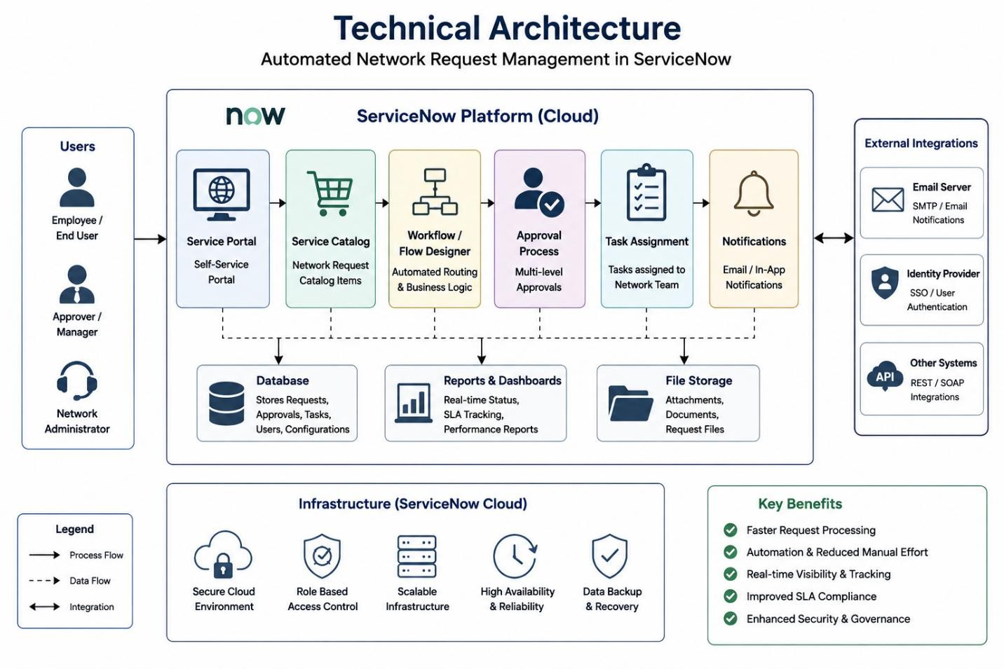

Table–1: Components & Technologies

S.No | Component | Description | Technology
1 | User Interface | Interface for users to submit and track requests | ServiceNow Service Portal, HTML, CSS
2 | Application Logic–1 | Request submission and validation | ServiceNow Business Rules
3 | Application Logic–2 | Workflow automation and approvals | ServiceNow Flow Designer
4 | Application Logic–3 | Task creation and notifications | ServiceNow Notifications
5 | Database | Store request and workflow data | ServiceNow Database
6 | Cloud Database | Cloud-hosted platform storage | ServiceNow Cloud Platform
7 | File Storage | Store attachments and request files | ServiceNow Attachment Management
8 | External API–1 | Optional integration for external systems | REST API
9 | External API–2 | Notification and communication services | Email Integration
10 | Automation Engine | Process automation | ServiceNow Workflow Engine
11 | Infrastructure (Server / Cloud) | Application hosting environment | ServiceNow SaaS Cloud

Table–2: Application Characteristics

S.No | Characteristics | Description | Technology
1 | Open-Source Frameworks | Frontend and portal technologies | HTML, CSS, JavaScript
2 | Security Implementations | Authentication, authorization and access control | Role-Based Access Control (RBAC), ACL
3 | Scalable Architecture | Supports increasing users and requests | Multi-tier Cloud Architecture
4 | Availability | Continuous availability through cloud deployment | ServiceNow Cloud Infrastructure
5 | Performance | Automated workflows and reduced manual processing | Flow Designer, Notifications

